Exposure Experiments and Cosmic Ray Detection

Exposure Experiments

While hypobaric chambers and particle accelerating facilities may also be used to measure the effects of space-like environments on biology, ground simulations are often (1) expensive to perform, (2) volume limited, and (3) unable to accurately mimic dynamic sunlight levels while generating other conditions present in near space (e.g., extreme dryness and coldness). Consequently, ground-based experiments tend to be short-lasting, small in size, and limited by artificial doses of radiation. In contrast, the stratosphere naturally produces a fuller suite of biological stressors expected in space – simultaneously applied – including real sunlight and high energy particles.

Samples can be loaded the morning of a launch and sometimes returned to the laboratory within one day after flying.

* Exposure, the simplest form of performing biological science in the stratosphere – essentially, transporting known quantities of model organisms to the upper atmosphere and returning samples to the surface for subsequent laboratory analyses.
* A payload in the middle portion of the stratosphere (~35 km above sea level) will be exposed to an environment similar to the surface of Mars: -

Temperatures generally around −36 °C, atmospheric pressure at a thin 1 kPa, relative humidity levels < 1%, and a harsh illumination of ultraviolet (UV) and cosmic radiation levels (about 100 W/m2 and 0.1 mGy/d, respectively) that can be obtained nowhere else on the surface of the Earth, including environmental chambers and particle accelerator facilities attempting to simulate space radiation effects.

Physical conditions

Earth’s stratosphere spans from about 17 to 50 km ASL containing air that is thinner, drier and generally colder than the tropospheric air below. Gases and aerosols are the main constituents of the stratosphere; most weather and precipitation occur in the troposphere.

Typical flights last for 2.0-2.5 hours and reach altitudes of approximately 30 km. Payloads are exposed to intense cosmic and ultraviolet radiation, temperatures below -60° C, and atmospheric pressures of approximately 0.01 atmospheres.

The composition of ionizing radiation environment that a biological payload will experience during a balloon flight is complex, changing with both altitude and inclination.

Neutrons will be the most hazardous radiation for multicellular biological studies in the stratosphere.

Two of the most important environmental conditions in the stratosphere that affect balloon payloads are: the increased exposure to cosmic rays and ultraviolet radiation.

Cosmic rays damage cells by indiscriminately ionizing molecules throughout the cells. Ultraviolet radiation damages cells by disrupting the structure of certain parts of the DNA molecule.

Microbes and seeds can be shielded from ultraviolet radiation by placing them inside of payload containers. However, because of their high energy, the thickness of the shielding material (such as lead) required to absorb the cosmic rays would make payloads prohibitively heavy. Thin shields actually increase the particle flux because they fail to absorb the showers of secondary particles that are created when the cosmic rays hit the shielding material. Other important environmental factors, such as low atmospheric pressure and temperature, can be mitigated by payload design.

Cosmic Ray Detection

Cosmic rays are atomic nuclei and electrons that streak through the Galaxy at nearly the speed of light. The Milky Way is permeated with them. Fortunately, our planet's magnetosphere and atmosphere protect us from most cosmic rays. Even so, the most powerful ones, which can carry a billion times more energy than particles created inside atomic accelerators on Earth, produce large showers of secondary particles in the atmosphere that can reach our planet's surface.

Where do cosmic rays come from? Scientists have been trying to answer that question since 1912, when Victor Hess discovered the mysterious particles during a high-altitude balloon flight over Europe. Galactic cosmic rays shower our planet from all directions. There's no definite source astronomers can pinpoint, although there is a popular candidate.

* "Most researchers are betting that cosmic rays come from supernova explosions," says Jim Adams of the NASA/Marshall Space Flight Center. When massive stars explode, they blast their own atmospheres into space. The expanding shock waves can break apart interstellar atoms and accelerate the debris to cosmic ray energies. Cosmic rays are subsequently scattered by interstellar magnetic fields -- they wander through the Galaxy, losing their sense of direction as they go.
* [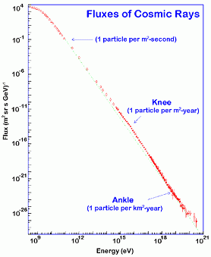](https://science.nasa.gov/files/science-red/s3fs-public/mnt/medialibrary/2001/01/10/ast15jan_1_resources/spectrumgif_med.gif)

Flux of cosmic rays bombarding Earth versus energy per particle.

Researchers believe cosmic rays with energies less than ~3x1015 eV come from supernova explosions. The origin of cosmic rays much more energetic than that (above the "knee" in the diagram) remain a mystery.

Composition: -

Of primary cosmic rays, which originate outside of Earth's atmosphere, about 99% are the nuclei of well-known atoms (stripped of their electron shells), and about 1% are solitary electrons (similar to [beta particles](https://en.wikipedia.org/wiki/Beta_particle)). Of the nuclei, about 90% are simple [protons](https://en.wikipedia.org/wiki/Proton) (i.e., hydrogen nuclei); 9% are [alpha particles](https://en.wikipedia.org/wiki/Alpha_particle), identical to helium nuclei; and 1% are the nuclei of heavier elements, called [HZE ions](https://en.wikipedia.org/wiki/HZE_ions). These fractions vary highly over the energy range of cosmic rays. A very small fraction are stable particles of [antimatter](https://en.wikipedia.org/wiki/Antimatter), such as [positrons](https://en.wikipedia.org/wiki/Positron) or [antiprotons](https://en.wikipedia.org/wiki/Antiproton).

* Cosmic rays can be divided into two types, **galactic cosmic rays** (**GCR**) and **extragalactic cosmic rays**, i.e., high-energy particles originating outside the solar system, and [**solar energetic particles**](https://en.wikipedia.org/wiki/Solar_energetic_particles), high-energy particles (mostly protons) emitted by the sun, primarily in [solar particle events](https://en.wikipedia.org/wiki/Solar_particle_event). However, the term "cosmic ray" is often used to refer to only the extrasolar flux.

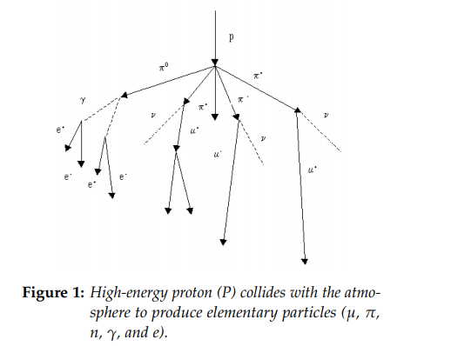

Methods: -

1. Exposure Experient

* Samples can be flown in small (5 cm × 5 cm) zip lock bags that are attached to the inside and outside of payload containers using transparent packing tape (Figure). Payload containers can be constructed from Polystyrene sheets available at hardware stores
* Samples attached to the outside of a container are exposed to both solar UV and cosmic rays. Samples on the inside of the containers are protected from ultraviolet light but not from cosmic rays.
* To monitor cosmic ray and UV intensity, temperature and other atmospheric variables during the flight, students should also integrate sensors and data loggers into their payload containers.
* Preparation of Yeast Cultures: -

We used a strain of common baking and brewing yeast, Saccharomyces cerevisiae containing a mutation that affects adenine biosynthesis (HA1). This strain turns red on yeast-extract dextrose (YED) media, a nutritionally complete medium containing a suboptimal amount of adenine. When grown on yeast-extract dextrose media with an excess of adenine (YEAD), the yeast will use adenine in the media instead of synthesizing it, and will grow into larger colonies and not turn red.

When grown on media with suboptimal adenine, HA1 grows until the colony exhausts the adenine and an intermediate metabolite in the biosynthesis pathway then causes the colony to turn red.

The visible colour mutations make this an ideal subject for investigating mutation rates. The genetics of yeast reproduction also allow for further research on the inheritance of new mutations

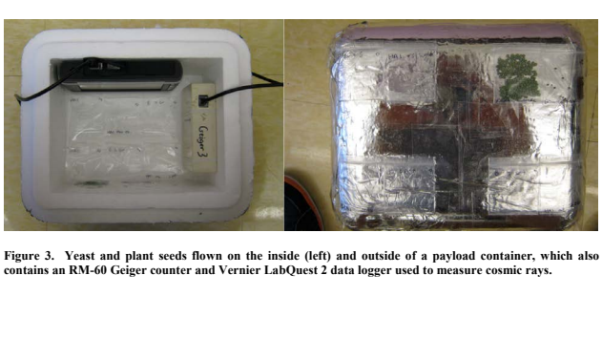

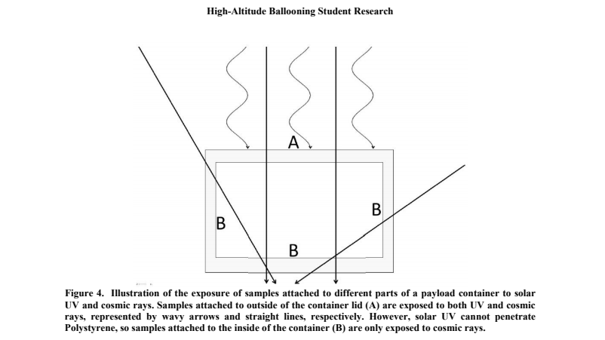

* Preparation of Plant Seeds: -

Ideal seeds are those that germinate on damp paper within a day or two, and have primary roots easily measured for short-term germination and growth studies. For longer studies, the seeds can be planted and should mature in 20-30 days.

We can use seeds of garden radish, Raphanus sativus, which are large and easy to handle.

Several dozen seeds can be put into the small zip lock bags. Figure 3 shows the four bags containing Brassica and radish seeds and the 12 bags containing yeast that were taped to the inside and the outside of the payload container for the flight.

1. Cosmic Ray Detection

Detection Methods: -

Direct detection is possible by all kinds of particle detectors at the [ISS](https://en.wikipedia.org/wiki/ISS), on satellites, or high-altitude balloons. However, there are constraints in weight and size limiting the choices of detectors.

* An example for the direct detection technique is a method developed by Robert Fleischer, [P. Buford Price](https://en.wikipedia.org/wiki/P._Buford_Price), and [Robert M. Walker](https://en.wikipedia.org/wiki/Robert_M._Walker_(physicist)) for use in high-altitude balloons:-

 In this method, sheets of clear plastic (like 0.25 [mm](https://en.wikipedia.org/wiki/Millimetre) [Lexan](https://en.wikipedia.org/wiki/Lexan) polycarbonate), are stacked together and exposed directly to cosmic rays in space or high altitude. The nuclear charge causes chemical bond breaking or [ionization](https://en.wikipedia.org/wiki/Ionization) in the plastic.

At the top of the plastic stack the ionization is less, due to the high cosmic ray speed. As the cosmic ray speed decreases due to deceleration in the stack, the ionization increases along the path.

The resulting plastic sheets are "etched" or slowly dissolved in warm caustic [sodium hydroxide](https://en.wikipedia.org/wiki/Sodium_hydroxide) solution, that removes the surface material at a slow, known rate. The caustic sodium hydroxide dissolves the plastic at a faster rate along the path of the ionized plastic. The net result is a conical etch pit in the plastic. The etch pits are measured under a high-power microscope (typically 1600× oil-immersion), and the etch rate is plotted as a function of the depth in the stacked plastic.

* In this experiment, we may use a ‘Geiger Counter’ to detect cosmic rays-

When a charged particle hits the high voltage neon gas inside the tube, the gas is ionized which sets off a chain reaction of electron flow which results in a ’pulse’ from the tube. Each pulse then corresponds to one high-energy particle.

Additionally, the Geiger counter subsystem will use an attached microcontroller and environmental sensor to parse and store the data locally on a micro SD card. After the flight, this card can be removed and used for data analysis. This data will be stored in a .CSV file containing a time stamp, counts per minute, internal temperature, pressure, and altitude.

Components Required: -

1. The payloads may be housed in insulated foam boxes/Styrofoam boxes. It may be wrapped in Al foil to provide the basic insulation, as well as radar reflection. Another way to provide better insulation would be to use- Kapton tape, which withstands a temperature down to -269 degrees Celsius.

The shape may be cubic (15×15×15cm) with wind-vane structure. The idea of having such a design is to align the payload always in one particular direction i.e. along the wind direction to limit the spinning of payload. This structure can be made from lightweight plastic ﬁbre.

1. Sensors
2. CO2 sensor [To measure CO2 content in the payload as the sample grows -yeast gives out Co2 while it undergoes ‘aerobic respiration’]
3. Pressure [To measure the difference in pressure at that altitude, and on ground]
4. Temperature [To measure the temperature that the samples are being exposed to, and compare with the temperature on land.]
5. Altitude [To know, at what altitude the samples are being exposed to these different conditions compared to the ground]
6. Geiger counter [It is designed to collect the occurrence of cosmic particles. The Geiger counter can detect charged particles by allowing them to pass through a high voltage tube.]
7. Battery(s) (Lightweight), 9-Volt
8. Controller Board- Arduino, Arduino Battery
9. Linear Actuator [To maintain centre of mass of the payload, and ensure greater stability]
10. Cameras [To observe the samples as it grows in the high-altitude conditions, as well as to click images of the surroundings as seen from the payload at high-altitude.]
11. Telemetry unit – (APRS Tracker, GPS Receiver)
12. Yeast and the seed samples

[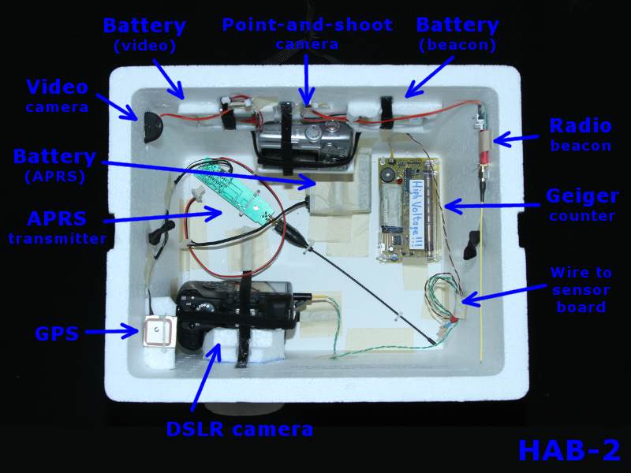](http://rocketsetc.com/wp-content/uploads/2015/05/hab2_payload2.png)

Sample arrangement for Payload (the equipment was held in place by Velcro strips, which were hot-glued to the cooler’s walls. It was arranged in a way to try distributing the weight evenly.

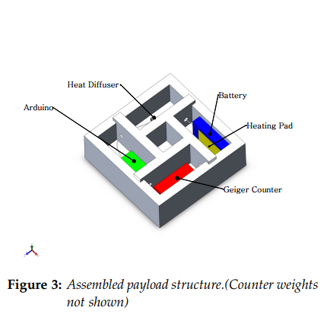

Sample payload structure (In addition to distributing external forces, the compartmentalized loading structure served to prevent electrical components from becoming dislodged and damaging each other while isolating the flight string to limit heat loss through its anchoring sites.)

References and additional sources-

1. <https://theunconventionalgardener.com/blog/stratospheric-seeds/>
2. <https://www.ncbi.nlm.nih.gov/pmc/articles/PMC6662212/>
3. <http://gravitationalandspaceresearch.org/index.php/journal/article/view/638/662>
4. <https://www.researchgate.net/publication/277722444_An_Overview_of_High-Altitude_Balloon_Experiments_at_the_Indian_Institute_of_Astrophysics>
5. <http://rocketsetc.com/high-altitude-balloon/hab-2/payload/>
6. <https://science.nasa.gov/science-news/science-at-nasa/2001/ast15jan_1>
7. <https://en.wikipedia.org/wiki/Cosmic_ray>
8. <https://pdfs.semanticscholar.org/1ee0/b6090adcd4c23ee24d8064031fa703a032b9.pdf>
9. <https://www.nasa.gov/feature/goddard/2017/nasas-supertiger-balloon-flies-again-to-study-heavy-cosmic-particles> (Expt. carried out by NASA)